An Overview - zOS Connect

Summary
z/OS Connect is designed to provide a fast, secure, reliable connector to reach any z/OS asset. It provides a standard way to identify these assets and reach the assets using REST technology. Where these assets run is specified in the z/OS Connect configuration, relieving clients applications in the cloud, mobile, and web worlds of the need to understand the details about how to reach them and how to convert payloads to and from the formats that the applications require.
It takes the power of IBM Z to the API economy, enabling you to drive new business opportunities through naturally RESTFUL APIs and JSON with integarated tools for DevOps. The rapid growth of APIs as a means of providing and consuming capability is a perfect match to the scalability and robustness of IBM Z. API management enables business to create, proxy, assemble, secure, scale and socialize API quickly and easily. Enterprises that run their Core business service on the Mainframe are now looking for ways to make those services easily discoverable and consumable as APIs.
z/OS Connect adds the API concept to the existing first class support to service enablement of Z assets with CICS, IMS, BATCH, IBM MQ and DB2.

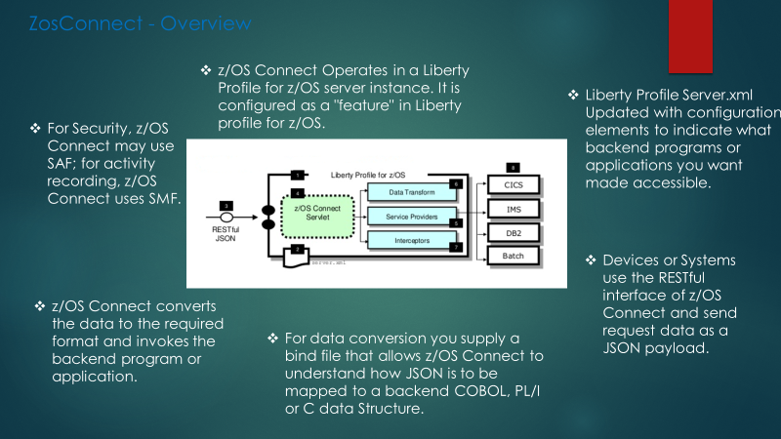
How do I use z/OS Connect Service provider (Inbound) ?
zOS Connect APIs are adapter APIs only to exposed through Internal API gateway as proxy to enable throttling and controls to be applied to each zOS Connect adapter API. This 'assets' need to be exposed as 'services' in order to offer them up as 'APIs' to potential consumers.
zOS connect has a discovery function that provide a list of configurable services and their specific details. Developer can use this when designing the applications that will access the z/OS system of record. Liberity profile has a natural ability to handle HTTP, RESTful services and JSON. zOS connect work with services like SAF, SMF etc to enhance the management and control of the access.
System Management Facility (SMF) is an activity of recording service of z/OS. It is very fast with low overhead and is used by most of subsystem. It can be enable to write SMF record for every request.
Security Access facility is a zOS security interface to an underlying security product such as RACF. It use the SAF interface to perform the security validations. It can be also use to verify authority access to connect with services
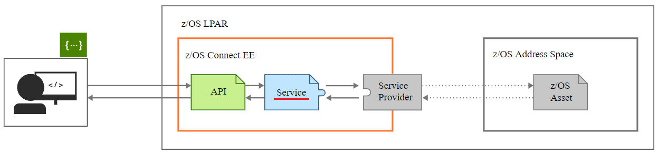

How do I set up an API?
A z/OS Connect service should be logically mapped to a mainframe application/transaction which receives certain inputs and provides certain outputs. One or more APIs may be bound to a single service. This is shown in the diagram below.

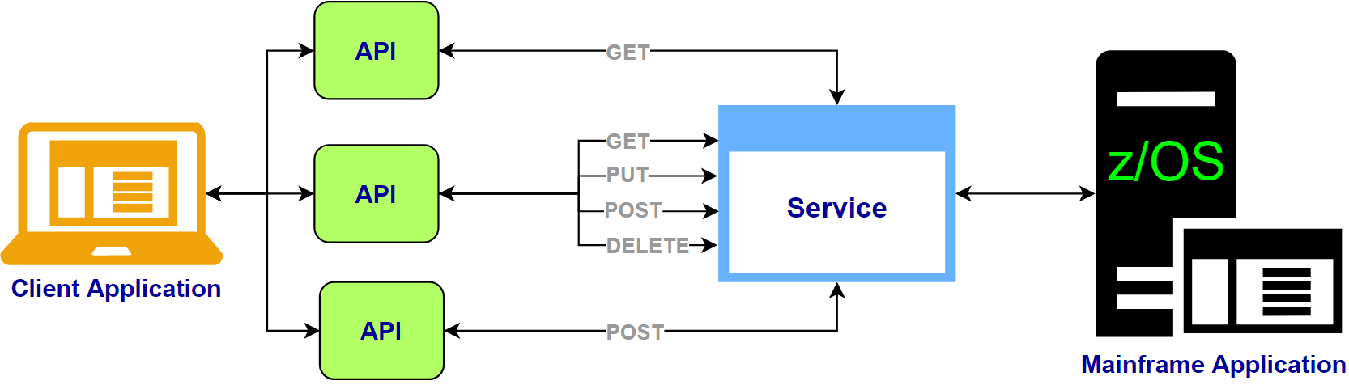

How do I use z/OS Connect API Requester (Outbound)?
z/OS applications can retrieve data synchronously or asynchronously from REST services and take action on the response/data returned. The API requester handles the translation from mainframe data definition to JSON data structures

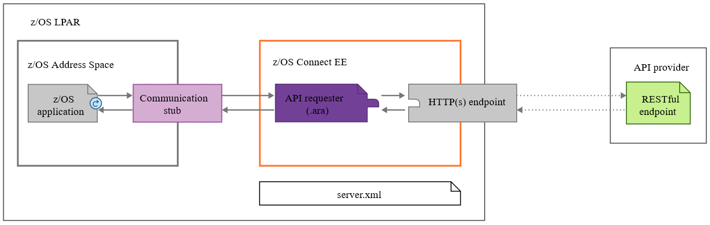

Service Archieve file is a schema which describes how we need to communicate with Backend Mainframe. This is how exactly your Input and Output layout looks like for the specific program/Transactions and the ZosConnect will have mapping internally with these layout to be communicated with Application in Mainframe. Afterthen, Input Data will be passed in the JSON format which Zosconnect can handle within to connect with the IMS or CICS connect.
Furthermore, Zosconnect will also act as a Service provider to the front end where as API Archieve file is an API which describes which services need to be invoked and to be build on top of Service created. It will be created with unique path to call the backend service where we should be able to control the data mapping as well. API Toolkit will generate its own swagger document.
We can expose single service into multiple functionality by defining more than one method. But every method can be used only one time in the particular API.

Benefits of using z/OS Connect
z/OS Connect adds value for z/OS customers by enabling users to consolidate multiple client connect pathways into a single common gateway or concentrator for synchronous calls to reach business assets and data on z/OS operating systems. Virtually any z/OS asset, applications and data, can be reached by using standard REST HTTP calls. This feature also provides the ability to inquire about, or discover, all assets that are defined in the z/OS Connect configuration repository. The following is a summary of the benefits of z/OS Connect:
- Provides RESTful access to identify and invoke z/OS-based business assets in CICS®, IMS, UNIX System Services, and traditional batch environments, opening up these assets to cloud and mobile-based system of engagement environments.
- Functionality that is based on Liberty server technology, is lightweight and easily configurable, and provides z/OS differentiation with System Authorization Facility (SAF) security integration, z/OS Workload Manager (WLM), and Resource Recovery Services (RRS) integration. WLM integration means different URIs can have varying levels of priority and performance criteria.
- As a feature in the Liberty server on z/OS, you can integrate z/OS Connect with z/OS standard system management, which can run as a started task and integrate with z/OS automated operations.
- Provides the ability to secure individual or groups of z/OS Connect services with SAF security in which only specific users or groups can have access to specific services.
- Provides the ability to uniformly track requests from cloud, mobile, and web environments by using z/OS System Management Facility (SMF) services. This tracking means that z/OS customers can use their existing processes for auditing and chargeback for requests from these environments.
- Enables the ability to do an automatic conversion of the request payload from JavaScript Object Notation (JSON) form on input to binary form consumable by z/OS applications such as Cobol, PL/I, and C. The reverse for the response from the z/OS application, converting the output from binary to JSON form is also true.

